
SMART STUDENT ANALYSIS SYSTEM
A Python-Based Student Performance Analysis Program

Project Report
Submitted By:
Name: Ragini Tomar
Registration No.: 26BAI10879
Course / Class: Introduction to problem solving and programming

Platform: Vityarthi - Build Your Own Project

Department: Artificial Intelligence and Machine Learning
Institute:VIT Bhopal
Academic Year: 2026–2027
1. Introduction
The Smart Student Analysis System is a Python-based application designed to analyze a student's academic performance based on the marks obtained in different subjects. The system takes the student's name and marks in five subjects—Python, Maths, English, Physics, and Communication—as input and processes the entered information to generate a student performance report.
The system uses various Python programming concepts, including functions, lists, loops, conditional statements, input validation, exception handling, arithmetic operations, and formatted output. These concepts are combined to process the student's marks and generate meaningful academic results [1].
The system validates the entered marks to ensure that they are within the valid range of 0 to 100. If the user enters a value outside this range or enters a non-numerical value, the system displays an appropriate error message and asks for the marks again. This helps maintain the correctness of the input data.
After receiving valid marks, the system calculates the total marks and percentage. Based on the percentage, it assigns a grade ranging from A+ to F. The system also determines the student's result as PASS or FAIL according to the defined passing criteria.
The project is designed as a console-based application that provides a simple and structured way to process student marks and generate an academic performance report. It focuses on accurate calculation, input validation, and clear presentation of the analysis results.

3. Problem Statement
In an academic environment, student marks are often recorded and analyzed manually. Calculating total marks, percentage, grade, and final result for each student can require repeated calculations and may lead to errors, especially when the entered marks are invalid.
The Smart Student Analysis System is developed to provide a simple way to process a student's marks and generate a performance report. The system accepts marks for five subjects—Python, Maths, English, Physics, and Communication—and validates each entered value to ensure that it falls between 0 and 100.
After receiving valid inputs, the system calculates the student's total marks and percentage, determines the appropriate grade, and displays the final result as PASS or FAIL. The problem addressed by the project is therefore to create a structured and reliable method for performing these basic student-performance calculations while handling invalid input appropriately.
The system focuses on input validation, automated calculation, grade classification, and result generation through a simple console-based interface.

4. Functional Requirements
The Smart Student Analysis System provides the following functional requirements:
4.1 Student Name Input
The system shall allow the user to enter the student's name. The entered name is displayed in the final student report.
4.2 Subject Marks Input
The system shall accept marks for the following five subjects:
- Python
- Maths
- English
- Physics
- Communication
The marks are entered individually for each subject.
4.3 Marks Validation
The system shall validate the entered marks and accept only values between 0 and 100. If the user enters a value outside this range, the system shall display an error message and request the marks again [1].
4.4 Invalid Input Handling
The system shall handle non-numerical input using exception handling. If the user enters an invalid value such as text instead of a number, the system shall display an appropriate error message and allow the user to enter the marks again [3].

4.5 Total Marks Calculation
The system shall calculate the total marks obtained by the student by adding the marks entered for all five subjects.
Percentage | Grade
90% and above | A+
80 to below 90 | A
70 to below 80 | B
60 to below 70 | C
50 to below 60 | D
below 50 | F

4.6 Percentage Calculation
The system shall calculate the student's percentage using the total marks and the number of subjects. The percentage shall be displayed up to two decimal places.
4.7 Grade Calculation
The system shall assign a grade according to the calculated percentage:
4.8 Result Generation
The system shall determine the final result based on the percentage. A percentage of 40% or above is displayed as PASS, while a percentage below 40% is displayed as FAIL.
4.9 Student Report Display
After processing all inputs, the system shall display a student report containing the student name, total marks, percentage, grade, and final result.

5. Non-Functional Requirements
The Smart Student Analysis System should not only perform its required calculations but also provide reliable, clear, and efficient operation. The following non-functional requirements define the quality characteristics of the system.
5.1 Usability
The system should be simple and easy to use. It provides clear prompts for entering the student's name and marks and displays understandable messages for valid and invalid inputs.
5.2 Reliability
The system should produce correct total marks, percentage, grade, and result when valid marks are provided. Input validation helps prevent incorrect marks from being processed.
5.3 Performance
The system should process the entered marks and generate the student report quickly without unnecessary processing or delay.
5.4 Error Handling
The system should handle invalid user input appropriately. The try-except mechanism is used to handle non-numerical input, while range validation ensures that marks remain between 0 and 100 [3].
5.5 Maintainability
The program should be easy to understand and modify. The use of separate functions such as get_valid_marks() and calculate_grade() makes individual parts of the program easier to manage and update.
5.6 Resource Efficiency
The system should require minimal system resources because it performs basic calculations and operates as a console-based application without requiring a database or other external services.

6. System Architecture
The Smart Student Analysis System is a simple console-based Python program that follows an Input–Processing–Output architecture. The user enters the student's name and marks for five subjects through the console. The program validates the entered marks, performs the required calculations, determines the grade and result, and finally displays the student report.
The system can be divided into the following main components:
6.1 Input
The program accepts the student's name and marks for five subjects: Python, Maths, English, Physics, and Communication.

6.2 Validation
The get_valid_marks() function validates the entered marks. It checks whether the marks are numerical and within the range of 0 to 100. Invalid values are rejected and the user is asked to enter the marks again [3].
6.3 Processing
After valid marks are entered, the program stores them in a list. The sum() function is used to calculate the total marks obtained by the student [2][5].
6.4 Percentage Calculation
The program calculates the percentage by dividing the total marks by the number of subjects [5]. The percentage is displayed up to two decimal places.
6.5 Grade and Result Calculation
The calculate_grade() function determines the grade according to the percentage. The program also determines whether the student has PASS or FAIL status using the defined condition.
6.6 Report Display
Finally, the program displays the student's name, total marks, percentage, grade, and result in the console.
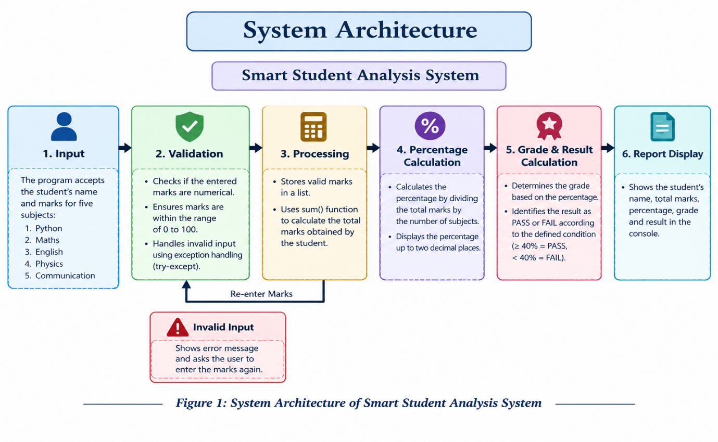
7. Design Diagrams
The design diagrams represent the interaction, workflow, sequence of operations, and logical components of the Smart Student Analysis System. Since the project is implemented as a single console-based Python program without a database or classes, the diagrams are based on the actual functions and processing flow used in the program.
7.1 Use Case Diagram
The Use Case Diagram represents the interaction between the user and the Smart Student Analysis System. The user enters the student's name and marks for the five subjects. The system validates the marks, performs the required calculations, determines the grade and result, and displays the final student report.

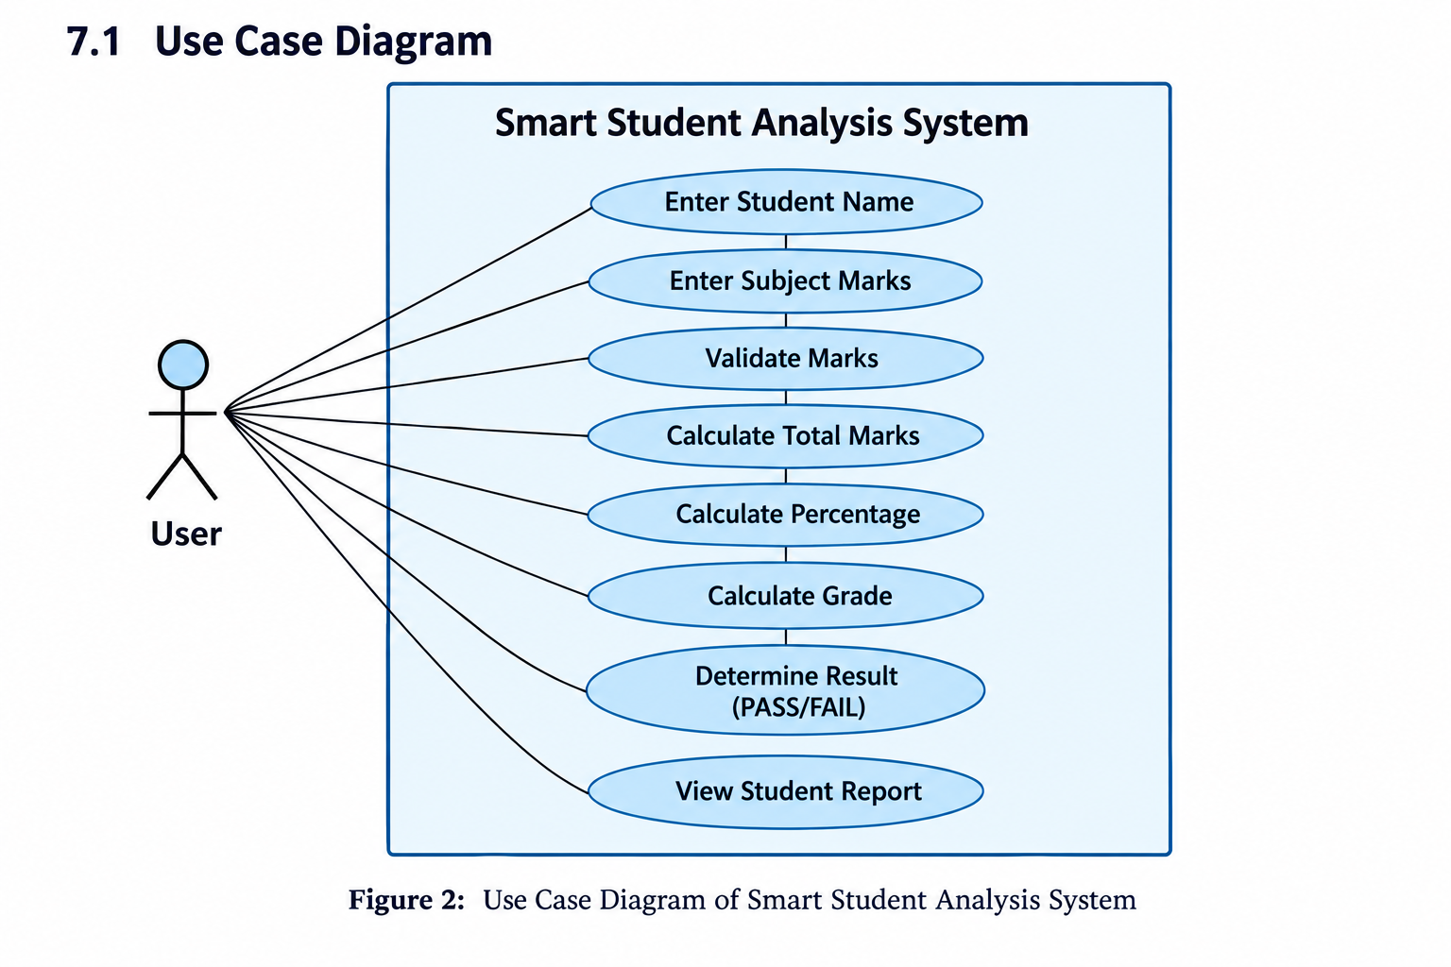
7.2 Workflow Diagram
The Workflow Diagram represents the step-by-step execution of the Python program. It shows how the system accepts input, validates marks, performs calculations, determines the grade and result, and finally displays the student report.

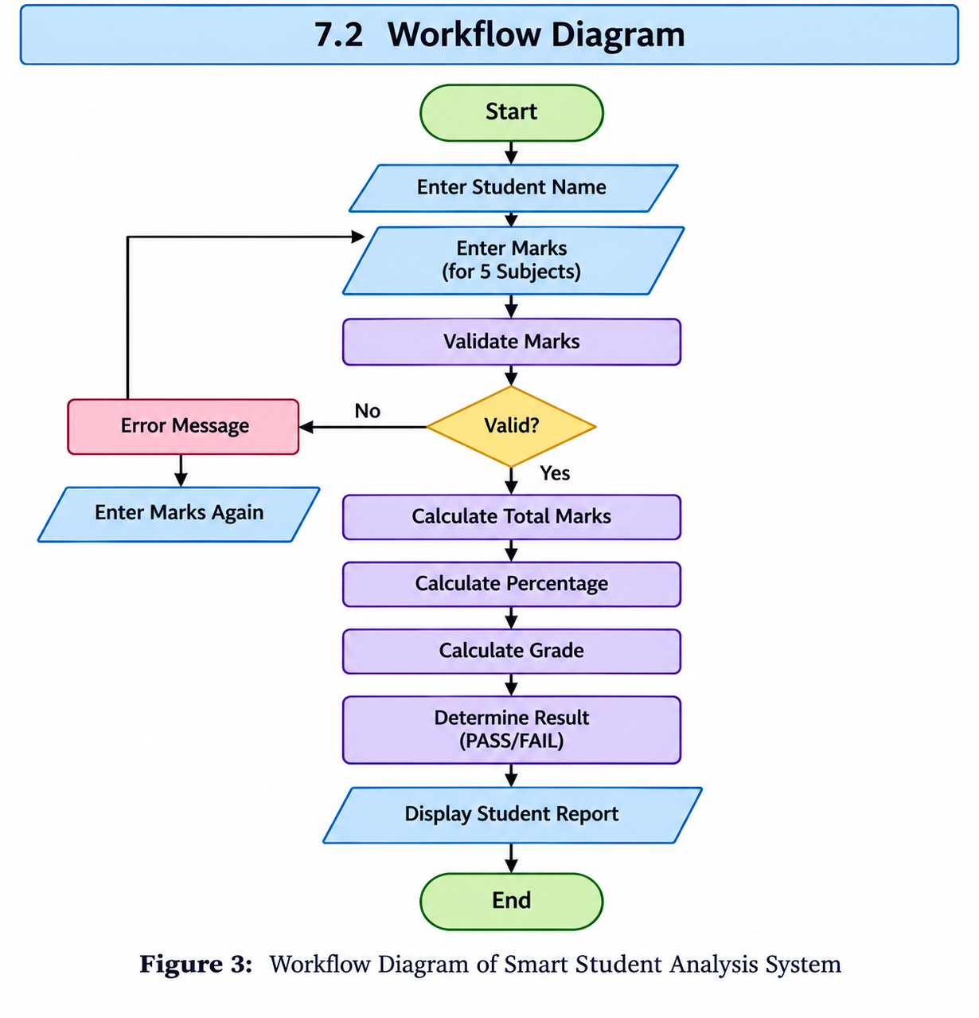

7.3 Sequence Diagram
The Sequence Diagram represents the order in which the user and the functions of the Python program interact. The main() function controls the overall execution, while get_valid_marks() validates the entered marks and calculate_grade() determines the grade.

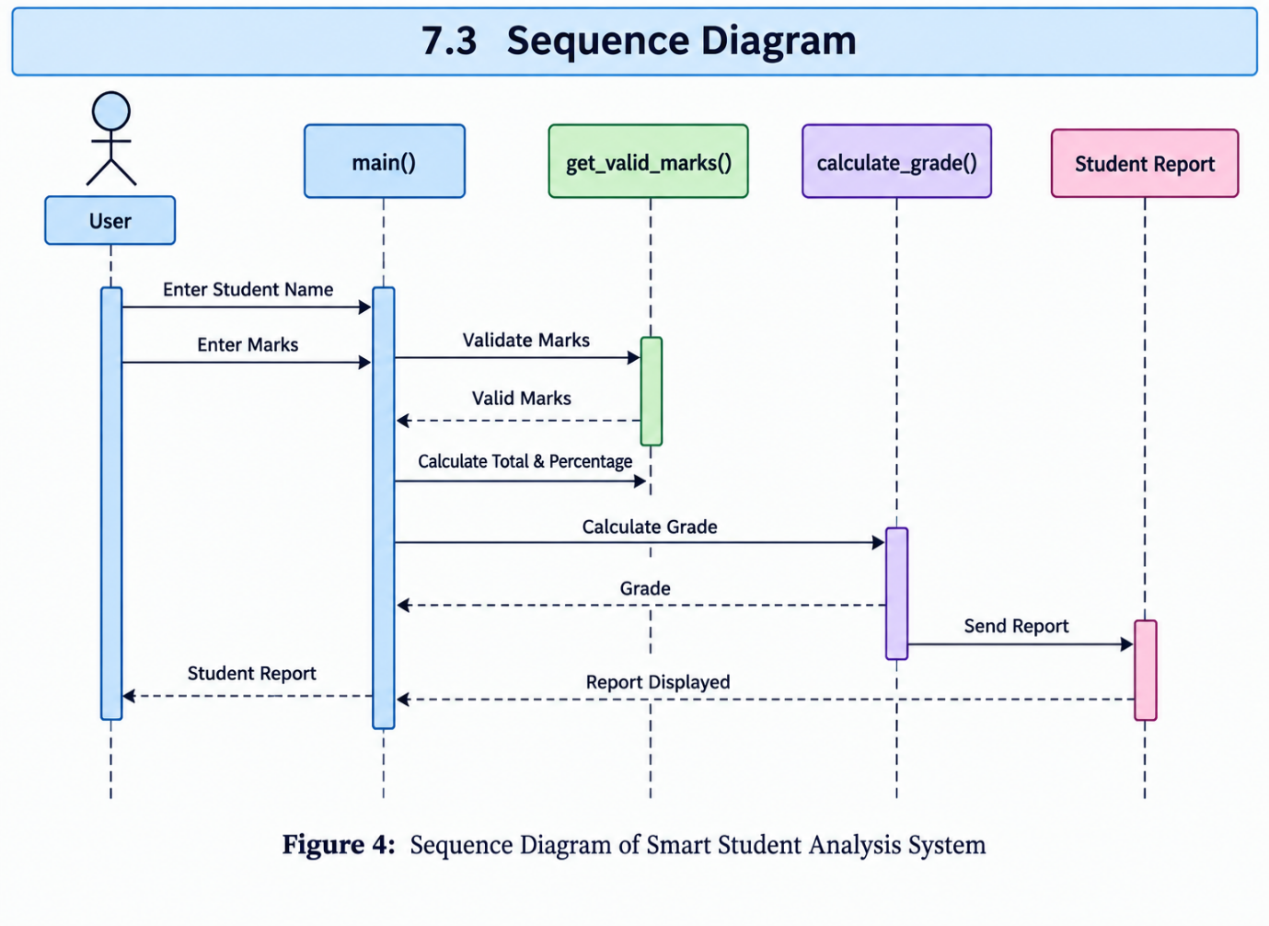

7.4 Component / Module Diagram
The current project is implemented in a single Python program. Therefore, the diagram represents the logical components of the program, rather than separate software files or classes. The main logical components are the main() function, get_valid_marks(), calculate_grade(), marks list, calculation section, and report display.

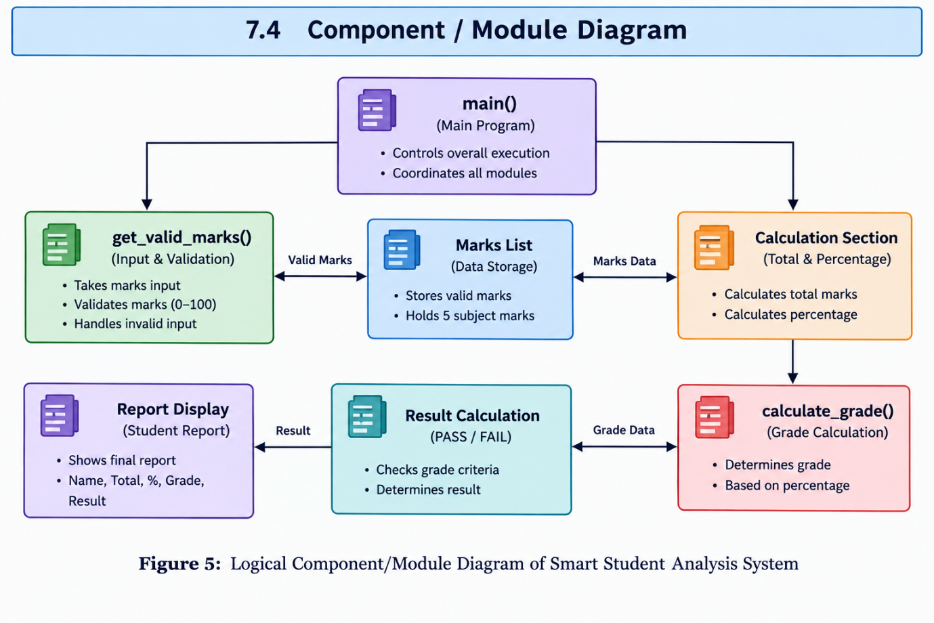

8. Design Decisions & Rationale
The following design decisions were made while developing the Smart Student Analysis System:
8.1 Use of Functions
The program uses separate functions such as get_valid_marks() and calculate_grade() to perform specific tasks. This makes the program easier to understand and maintain [1].
8.2 Input Validation
Marks are validated using the get_valid_marks() function. The program accepts marks only between 0 and 100 and handles invalid numerical and non-numerical inputs.
8.3 Use of List
A list is used to store the marks of the five subjects. This allows the program to process all subject marks efficiently using common operations such as sum() [2].

8.4 Grade Classification
The calculate_grade() function uses conditional statements to classify the student's grade according to the calculated percentage.
8.5 Console-Based Interface
The project uses a simple console-based interface because the main purpose of the program is to demonstrate student-mark input, validation, calculation, and report generation without requiring additional interface components.
8.6 Simple Program Structure
The program is kept as a single Python script with a main() function controlling the overall execution. This keeps the implementation straightforward and suitable for the scope of the project.

9. Implementation Details
The Smart Student Analysis System is implemented as a single Python program. The implementation focuses on taking student information and marks as input, validating the entered marks, performing calculations, assigning a grade, determining the result, and displaying the final student report.
9.1 Program Structure
The program contains three main functions:
- get_valid_marks(subject_name) – accepts marks for a subject and validates the input.
- calculate_grade(percentage) – determines the grade based on the calculated percentage.
- main() – controls the complete execution of the program, including input, calculations, result determination, and report display [1].
9.2 Input Handling
The program first asks the user to enter the student's name. It then uses a predefined list of five subjects: Python, Maths, English, Physics, and Communication.
Marks are entered separately for each subject.

9.3 Marks Validation and Exception Handling
The get_valid_marks() function uses a while loop and try-except block to handle invalid input [3][4] .
The program checks that:
- The entered value is numerical.
- The marks are between 0 and 100.
If the value is invalid, an appropriate error message is displayed and the user is asked to enter the marks again.
9.4 Calculation Process
After valid marks are entered, they are stored in a list. The program calculates:
- Total Marks using sum(marks) [5].
- Percentage using total / len(subjects) [5].
- Grade using the calculate_grade() function.
- Result using the condition percentage >= 40 [2].
9.5 Output Generation
Finally, the program displays a student report containing:
- Student Name
- Total Marks
- Percentage
- Grade
- Result (PASS/FAIL)
The percentage is displayed up to two decimal places using formatted output.

10. Screenshots / Results
The Smart Student Analysis System was executed successfully in the Python terminal. The following output shows the student details, subject-wise marks, total marks, percentage, grade, and final result generated by the program.
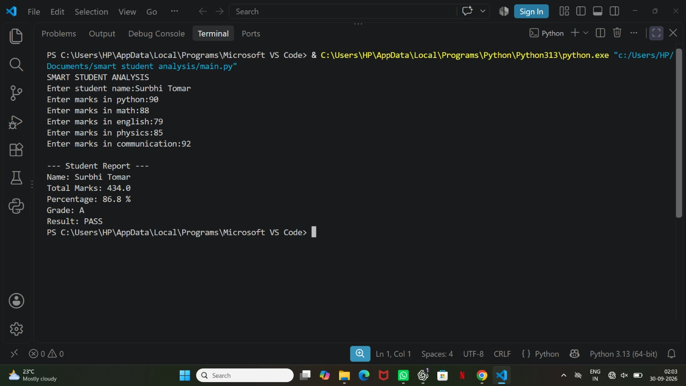

10.1 Sample Execution Result
The Student name entered was Surbhi Tomar. The marks entered for the five subjects were:

- Python: 90
- Maths: 88
- English: 79
- Physics: 85
- Communication: 92
The program generated the following result:
- Total Marks: 434.0
- Percentage: 86.8%
- Grade: A
- Result: PASS
The output confirms that the program successfully accepts the subject marks, calculates the total and percentage, assigns the appropriate grade, and determines the final result.

11. Testing Approach
The Smart Student Analysis System was tested by checking the different input conditions and processing rules implemented in the Python .py program. The testing focuses on marks validation, invalid input handling, total and percentage calculation, grade calculation, and PASS/FAIL determination.

11.1 Test Cases

Test Case | Input / Condition | Expected Output
TC01 | Valid marks (0–100) | Marks accepted
TC02 | Marks below 0 or above 100 | Invalid marks message
TC03 | Non-numerical input | Invalid input message
TC04 | Valid marks for all 5 subjects | Total and percentage calculated
TC05 | Percentage 90 and above | Grade A+
TC06 | Percentage 80 to below 90 | Grade A
TC07 | Percentage 70 to below 80 | Grade B
TC08 | Percentage 60 to below 70 | Grade C
TC09 | Percentage 50 to below 60 | Grade D
TC10 | Percentage below 50 | Grade F
TC11 | Percentage 40 and above | PASS
TC12 | Percentage below 40 | FAIL

These test cases cover the main conditions implemented in the program and verify that the system accepts valid inputs, handles invalid inputs correctly, performs the required calculations, assigns the appropriate grade, and determines the final result.

12. Challenges Faced
During the development of the Smart Student Analysis System, the following challenges were encountered:
12.1 Handling Invalid Marks
The program needed to ensure that marks entered by the user were within the valid range of 0 to 100. This was handled using conditional validation.
12.2 Handling Non-numerical Input
Users may enter text or other non-numerical values instead of marks. The try-except block was used to handle such input and display an appropriate error message [3][4].
12.3 Repeated Input for Invalid Values
When invalid marks are entered, the program should not continue with incorrect data. A while loop was used in get_valid_marks() to repeatedly ask the user for valid marks.
12.4 Correct Grade and Result Calculation
The program required separate conditions for assigning grades from A+ to F and determining PASS or FAIL based on the calculated percentage.
12.5 Maintaining a Simple Program Structure
Since the project is implemented as a single Python .py program, the functions and calculations were organized clearly to keep the code simple and understandable.

13. Learnings & Key Takeaways
The development of the Smart Student Analysis System provided practical understanding of Python programming concepts and basic program development.
13.1 Python Functions
The project helped in understanding how functions such as get_valid_marks(), calculate_grade(), and main() can be used to organize program tasks [1].

13.2 Input Validation
The project provided practical experience in validating user input and ensuring that marks remain within the valid range of 0 to 100.
13.3 Exception Handling
The use of try-except helped in understanding how a Python program can handle non-numerical input without terminating unexpectedly [3][4].
13.4 Conditional Statements
The project improved understanding of if, elif, and else statements for grade classification and PASS/FAIL determination.
13.5 Lists and Calculations
The project provided experience in storing subject marks in a list and using operations such as sum() and len() for calculations [2][5].
13.6 Program Flow
The project helped in understanding how input, validation, processing, calculation, and output are connected in a Python console program.

14. Future Enhancements
The current Smart Student Analysis System is a simple Python .py console program. The following enhancements can be considered for future versions:
14.1 Multiple Student Records
The program can be extended to process and manage marks for multiple students instead of a single student at a time.
14.2 Additional Subjects
More subjects can be added to make the system suitable for different academic requirements.

14.3 Detailed Performance Analysis
The program can be enhanced to provide additional analysis of the student's subject-wise performance.
14.4 Improved Output Format
The student report can be presented in a more structured format to make the calculated information easier to read.
14.5 Data Storage
A future version can include a suitable method for storing student records so that previously entered information can be accessed later.

15. References
[1] Python Software Foundation, Python 3 Documentation, Python Software Foundation, 2025.
[2] Python Software Foundation, Built-in Types — Lists, Python Documentation, 2025.
[3] Python Software Foundation, Errors and Exceptions, Python Documentation, 2025.
[4] Python Software Foundation, Built-in Exceptions, Python Documentation, 2025.
[5] Python Software Foundation, Built-in Functions — sum() and len(), Python Documentation, 2025.

